Approaches to HOR Constraints

1. Customer modifies the form directly
- On the form, simply check/uncheck Visible and Required checkboxes for each control.
- If the form was designed by Siemens, customer first makes a copy of it, then edits it.
- If the customer designed the form, customer has full control and checks/unchecks as needed.
- Recommend using embedded forms to encapsulate the view of specific classes. For example, keep physician view in one embedded form. Thus, checking/unchecking is centralized in one place for a given class.

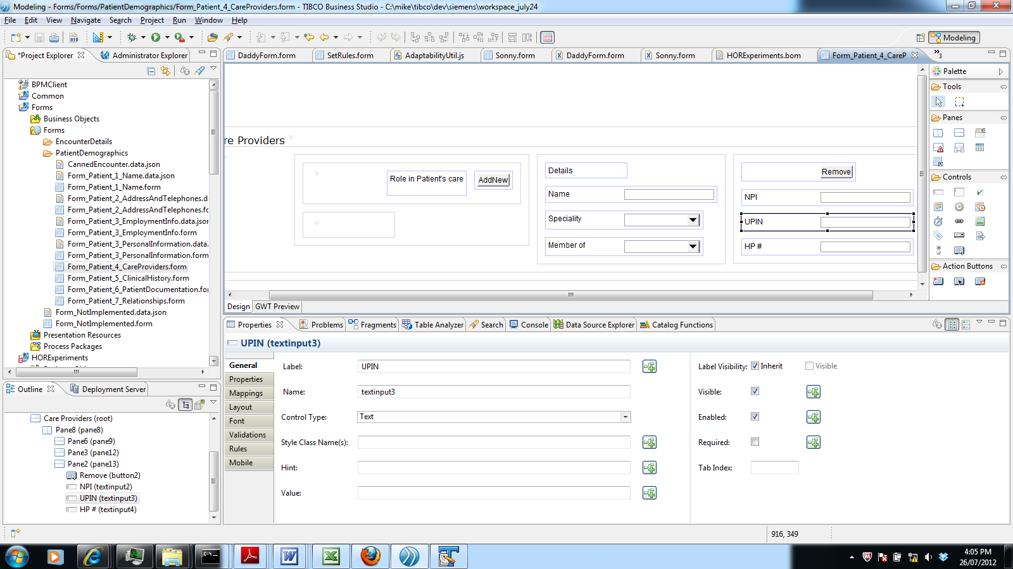

Advantanges:
- No need to build HOR management into adaptability framework.

Disadvantages:
- Customer must touch the code.
- Changes require redeployment.

2. Siemens provides model forms that are parameterized for HOR
- Siemens designs the form so that Visible and Required are set by a rule, which evaluates a boolean flag that is defined in the form's input data.
- Customer passes in the flags as input.
- How does customer know how to set these flags? Here we assume customer hard-codes them. In #3 below, they come from HOR tool.

Advantanges:
- No need to build HOR management into adaptability framework.
- Customer does not need to touch the code.

Disadvantages:
- Form logic is more complex.
- Form interface is more complex. Customer needs to pass in flags.
- Customer might specify the wrong field names. Use convention of XPath-based names to reduce guesswork, but still not perfect.
- Changes require redeployment.

3. Siemens provides HOR management framework, and forms are designed to use it
- Each form at load time loads its HOR settings from the framework. The settings specify for each field in the form whether to make it visible and required. The form programmatically enforces these settings field by field. (Alternatively - the customer could pass them as input, or the hosting page could provide them.)
- The settings are defined in a UI tool, similar to what SF uses today.
- Any Siemens-provided forms would be designed to use this framework. Customer-provided forms would need to follow the approach.

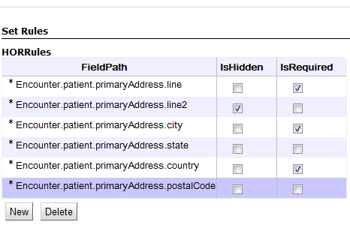

Advantanges:
- HOR settings can be managed in a separate tool.
- Can potentially hot-deploy these changes.

Disadvantages:
- Complexity - requires UI tool and other framework.
- Mapping from HOR configuration to form field is difficult and inexact.
- Can't depend on field naming. I.e., can't say in UI tool that the field known on the form as X should be visible.
- Can't determine field binding programmatically.
- A field need not be bound directly to a BOM attribute. The binding might be based on a computation.

-

Recommendation
- Combination of 1 and 2: 2 for small customers who don't want to touch code.

